User manual New Item Registration (NIR) application

This is one of MDM PowerApps was created to simplify the NIR request process. In this manual you will read how you can request an item and what all the app functions are.

You can find the app on [Certis Belchim shared space](https://certisbelchim.sharepoint.com/sites/homepage) - Home (sharepoint.com),

or [Master Data Management Portal](https://apps.powerapps.com/play/e/0835fe1a-a45a-4b85-abd7-ee4d76f74169/a/8a4f9885-e6d4-4f0c-bd82-6b282a94cfe3?tenantId=dccf612f-9071-4470-b170-c792b49c97a4). In case you have not found the link please contact Support Power Platform [<support.powerplatform@certisbelchim.com](mailto:%3csupport.powerplatform@certisbelchim.com)>.

Also, there are tutorial videos on how to use the NIR app, click this link to watch: [Videos](https://certisbelchim.sharepoint.com/sites/worksupportDigitalInnovation/Support/Forms/AllItems.aspx?viewid=927ddb6a%2D9a65%2D4ab8%2Da6de%2D1682a59cf0fc&id=%2Fsites%2FworksupportDigitalInnovation%2FSupport%2FNew%20Item%20Registration%20%28NIR%29%2FVideos)

Inhoud

1. How to request a new item 1

1.1 Based on existing information (Currently not available) 2

1.2 Blank NIR 5

2. How to view requested items 7

2.1 Resubmit a rejected request 8

3. For approvers 8

4. Contacting information 10

## How to request a new item

To request a new item please start the app. On the homepage you will find a green button (pointed to with a red arrow below). On this button “New NIR” is written. Click this button.

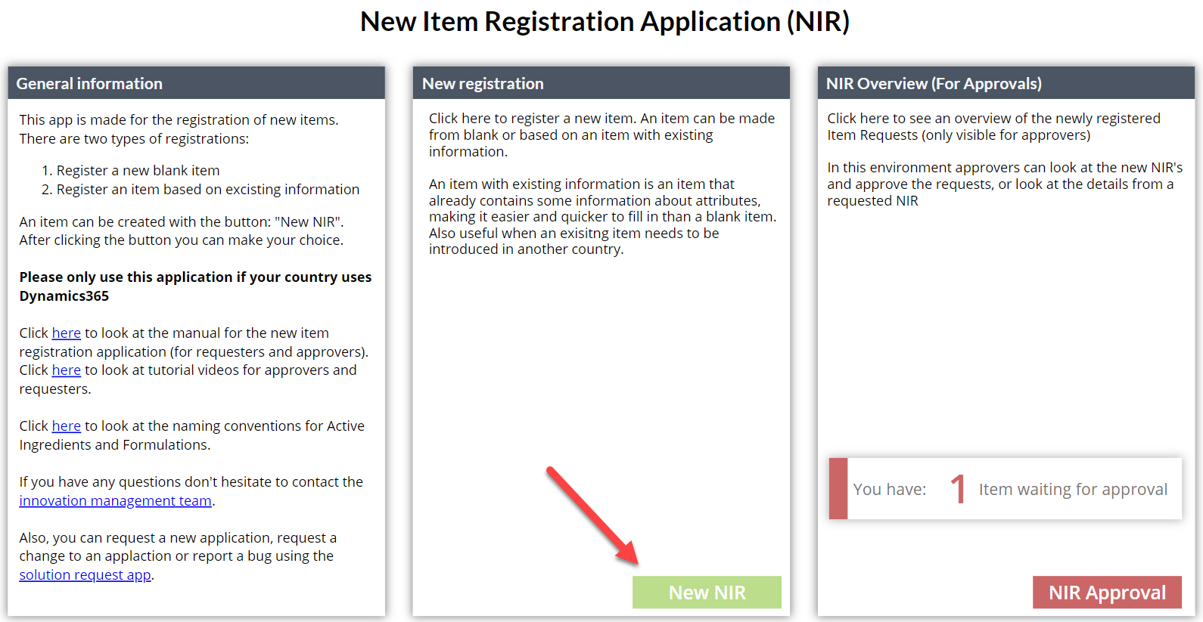

After clicking on the button, you will be sent to a new page. On this page you will be able to make a choice. The choices are: 1.1 Blank NIR based registration and 1.2 NIR registration based on existing information. Below you will find both choices explained.

## Based on existing information (Currently not available)

By clicking this button (pointed to with a red arrow in the image below) you will be able to request a new item based on an item or information that is already in dynamics.

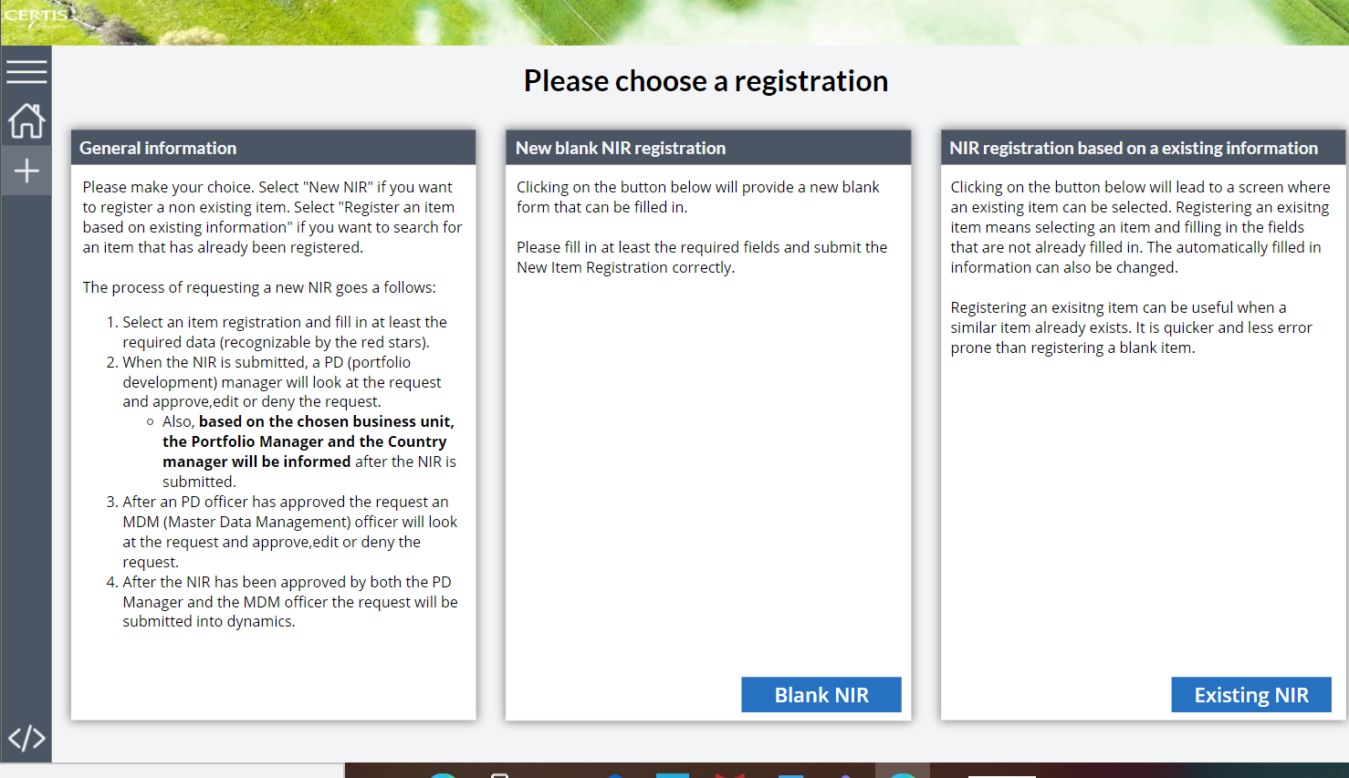

A different page will be visible. On this page you will be able to search for an item to copy. To search click on the grey search bar (highlighted yellow in the image below). You can search by product name, formulation, QC code, Item number and Active Ingredient.

Please note that it could happen that the item you are looking for is available in dynamics but not available in the app. This is due to the fact that the app uses an export from a database. It could take some time for the data to be exported. For any questions you can contact the Support Power Platform <support.powerplatform@certisbelchim.com>.

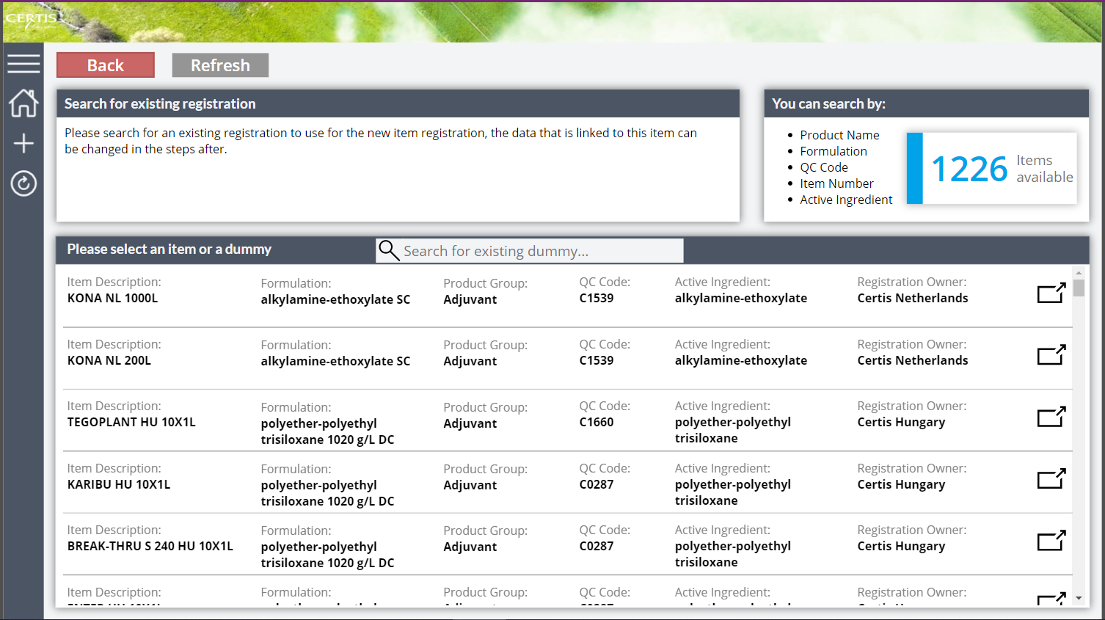



If you have found the item, you were looking for click the highlighted button to open a new page with the item that you want.

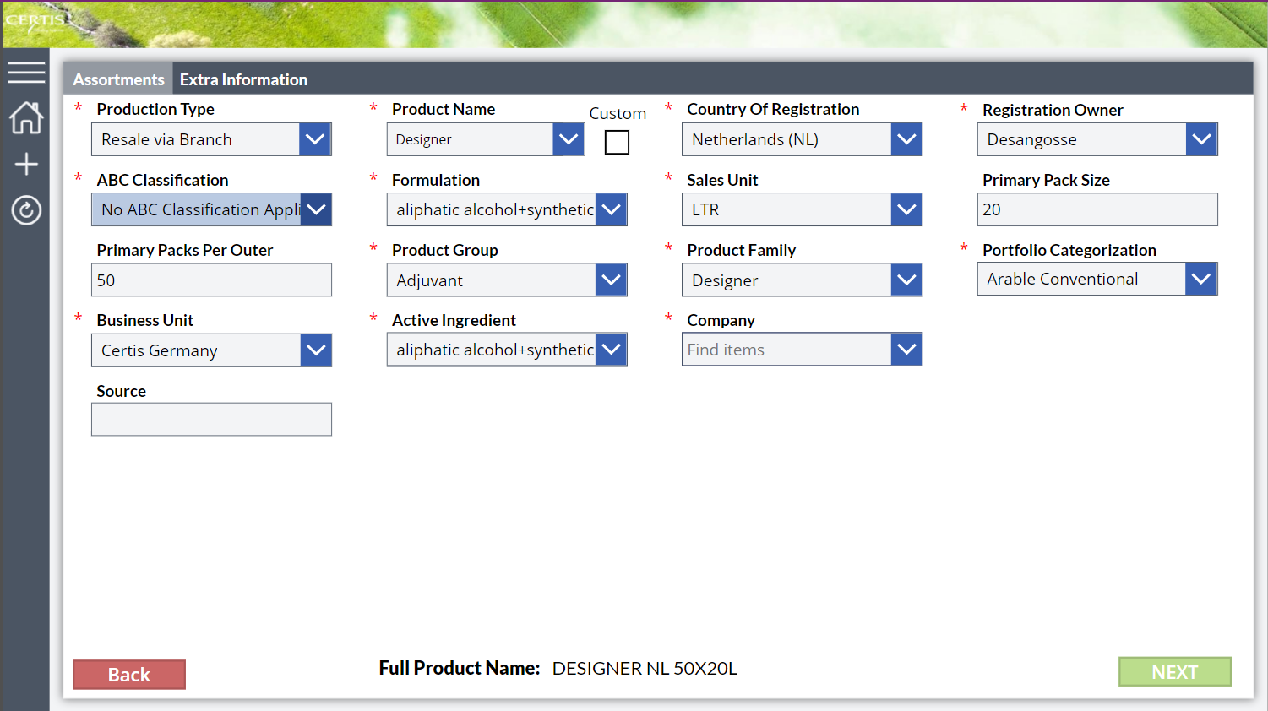After clicking this button, a page will open that looks like the page below this text. In this page it is possible to change a couple of fields. To change the data in the fields you simply have to click on the bar where the text is in. Bars with a blue arrow on the side are drop down menus. To find the data you are looking for in a drop-down menu you can search for the data. Please note that if you search for data instead of scrolling you must type the data in the same order as it exists in dynamics in.



All fields with a red star are mandatory. Please fill in all the mandatory fields, as it is not possible to request an item otherwise.

After filling in all the mandatory fields and fields you want to fill in on the first page you can add some extra information on the second page. To go to the second page please click on the “Extra Information” button (Marked yellow in the image above).

If you want to go back to the first screen you can navigate by clicking on the button “Assortments” next to the yellow marked button or click on the red “Back” button.

The extra information page looks like the page below. The way of filling out this page is the same as the first page.

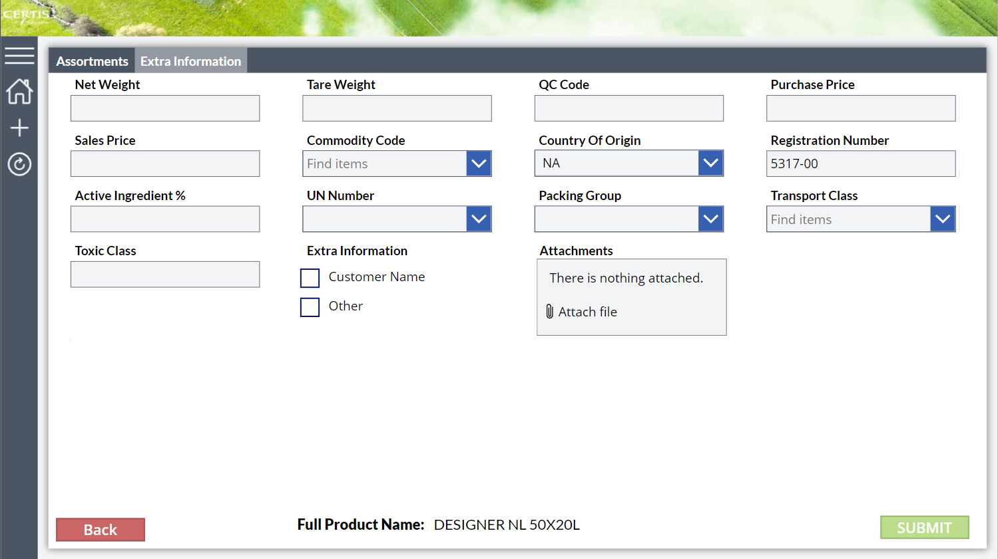

When all the data that you have wanted to add has been typed in you can send the form. Please note that the send button will remain locked till all required fields have been filled. When clicking on the send button when the mandatory fields are not filled in the following screen can be seen. The red border colour appears when field is not filled in correctly or empty.

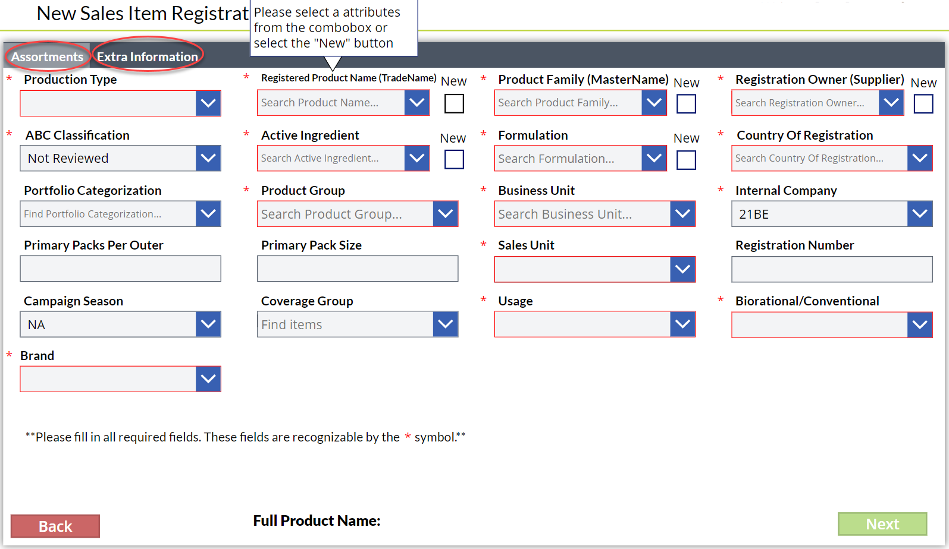

Please also note that it is mandatory to check with the portfolio lead and the country manager if this request is needed and if the data is correct. When sending a popup will require you to declare that this step has been done. After you have sent the request, an informative e-mail will be sent to the portfolio lead and the country manager.

If all the steps above have been executed then I applaud you, for the NIR request has been sent. A confirmation email will be sent to you with some of the data that you have filled in.

## Blank NIR

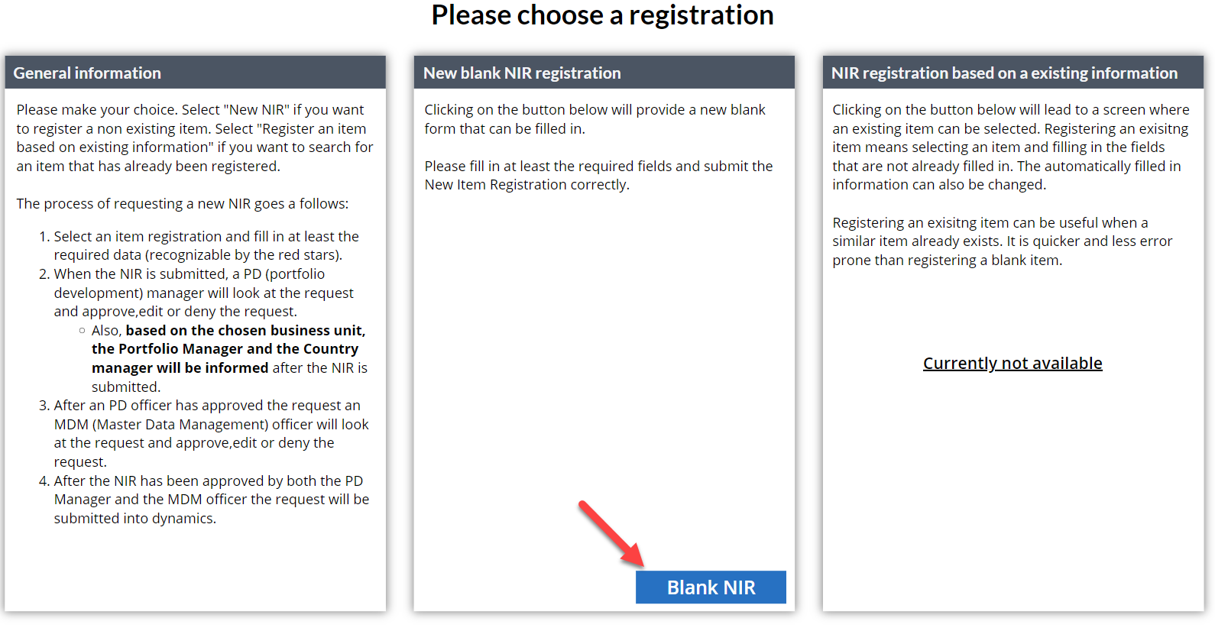

To request a NIR from blank please click the button “Blank NIR” (with a red arrow pointed to it).

When this is done a new page will open.

To fill out the form, you simply must click on the bar’s bellow the information type. Bars with a blue arrow on the side are drop down menus. To find the data you are looking for in a drop-down menu you can search for the data. Please note that if you search for data instead of scrolling you must type the data in the same order it exists in dynamics in.

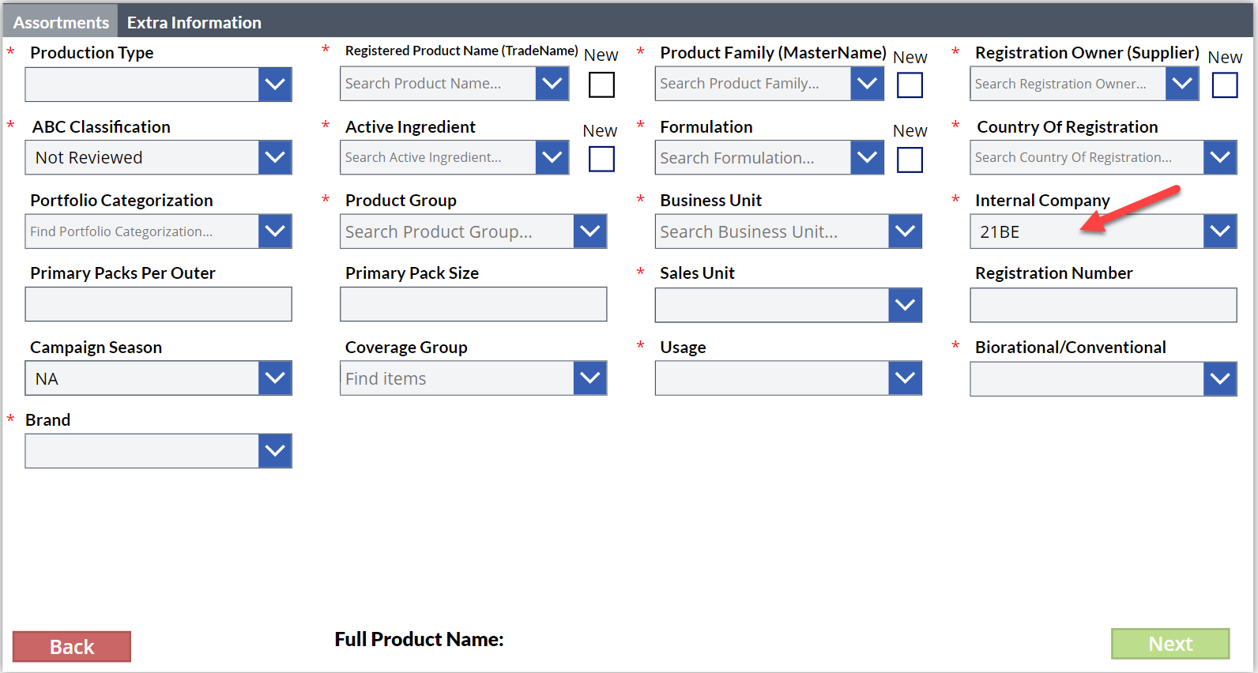

All fields with a red star are mandatory. Please fill in all the mandatory fields, as it is not possible to request an item with unfilled mandatory fields.

After filling in all the mandatory fields and fields you want to fill in on the first page you can add some extra information on the second page. To go to the second page please click on thebutton (Marked red oval in the image above).

If you want to go back to the first screen you can navigate by clicking on the button or click on the red “Back” button.

The extra information page looks like the page below. The way of filling out this page is the same as the first page.

When all the data that you have wanted to provide is filled in, you can “Submit” the form. Please note that the "Submit” button will remain locked till all required fields have been filled. If the mandatory fields are not filled in correctly the screen below will be shown. The red border colours appear when an entry field is not filled in correctly or empty.

Please also note that it is mandatory to check with the portfolio lead and the country manager if this request is needed and if the data is correct. When sending a popup will require you to declare that this step has been done. After you have sent the request, an informative e-mail will be sent to the PD (Portfolio Development) and the country manager.

If all the steps above have been executed then I applaud you, for the NIR request has been sent. A confirmation email will be sent to you with some of the data that you have filled in.

## How to view requested items

To view the items that you have requested you simply have to go to the item overview page. You can do that by going to the home page and clicking the button “NIR overview” (red arrow). 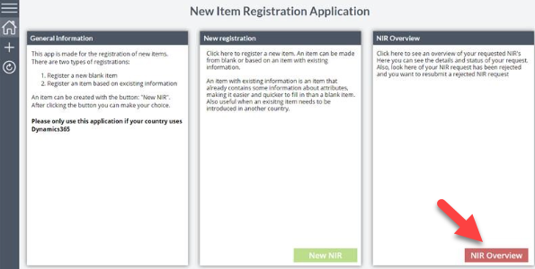

In this overview all items that you have requested are displayed. This screen is perfect for when an item is rejected. Instead of filling in a new NIR request you can edit a rejected NIR request and resubmit this request. To view your requested items simply click on the right end of the item. In this view you can also track the status of your item. As seen in the screen below, serviceaccount has requested 3 items. 1 of these items has been approved and is now in Dynamics. Another item is still wating for approval from one of the two approvers. And one item that has been rejected.

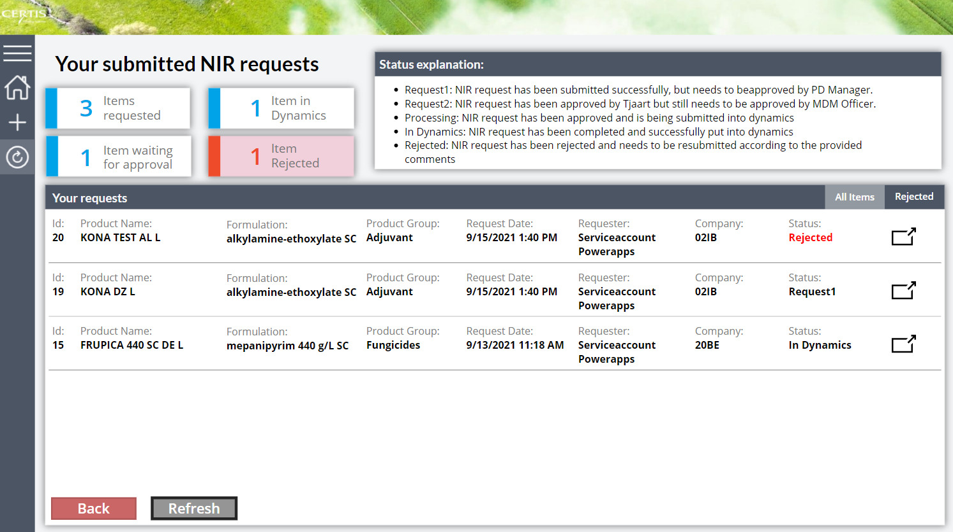



## Resubmit a rejected request

As you can see in the overview of the requested items, one is rejected by one of the two approvers. When clicking on the icon on the right (Highlighted in red) a form will open. This form is only editable when the status is “Rejected”.

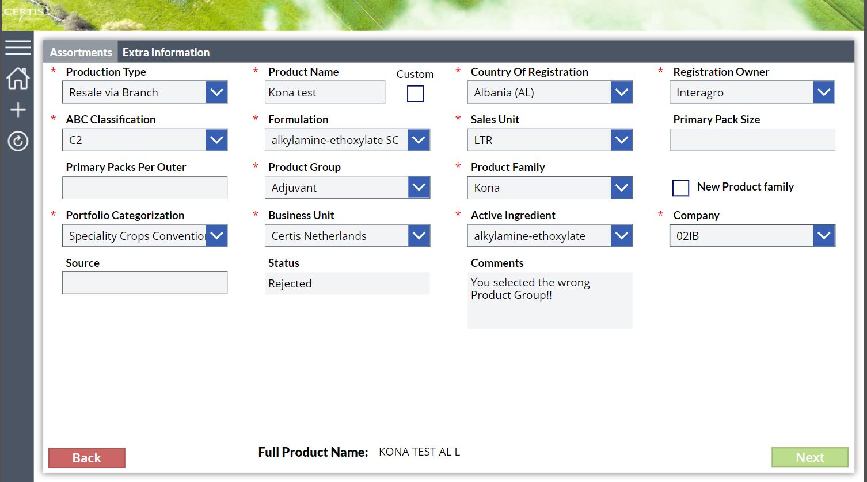

The approver must leave a comment as to why the request has been rejected, which can be seen in the form (red arrow). The form is the same as the one that was rejected so you will only have to adjust the form according to the comments and resubmit it instead of making a whole new request.

## For approvers

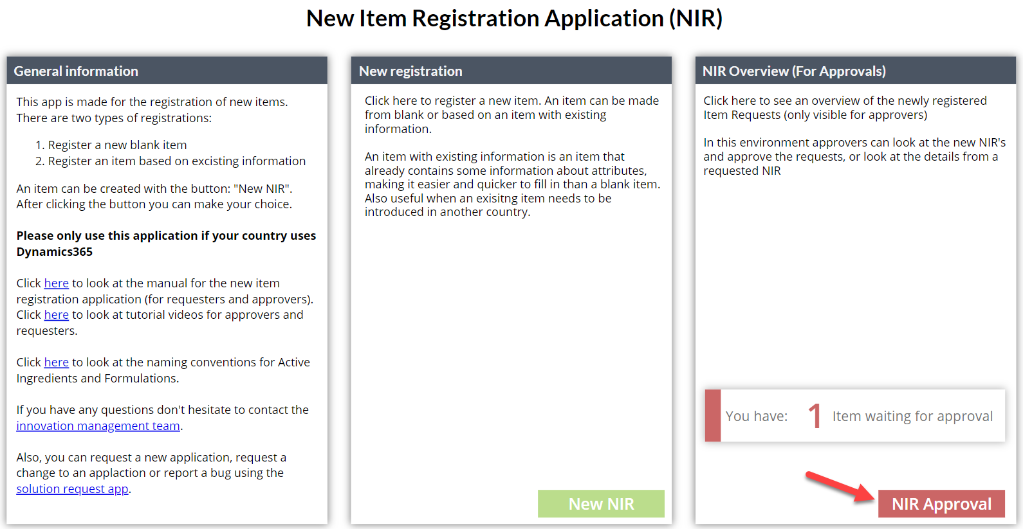

To approve an item, go to the home page and click the button “NIR Approval”. A view like the one below will be opened. To review an item and approve it click on the right end corned of the item (Marked with arrow). A PD (Portfolio Development) Manager will automatically have the filter set on “Request 1” and an MDM officer will automatically have the filter set on “Request 2” because these are the requests they should approve/reject.

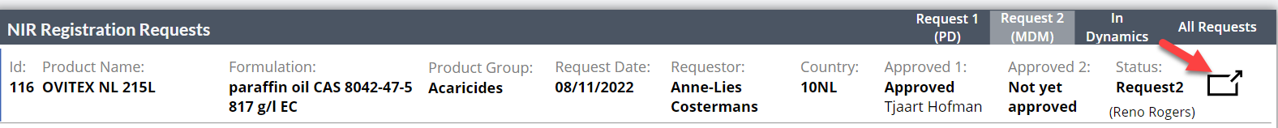

A View like the one below will be opened. In this view it has made possible to review the data, edit the form and approve it or reject the form. You can approve the item by clicking next, followed by clicking approve. An approver can also deny the request by clicking on “Reject”, which is only possible if comments are filled in. Lastly, if an item has a product name or a product family which is not in the combobox list but is custom made, this will be shown on the screen so there can be extra focus for these fields.

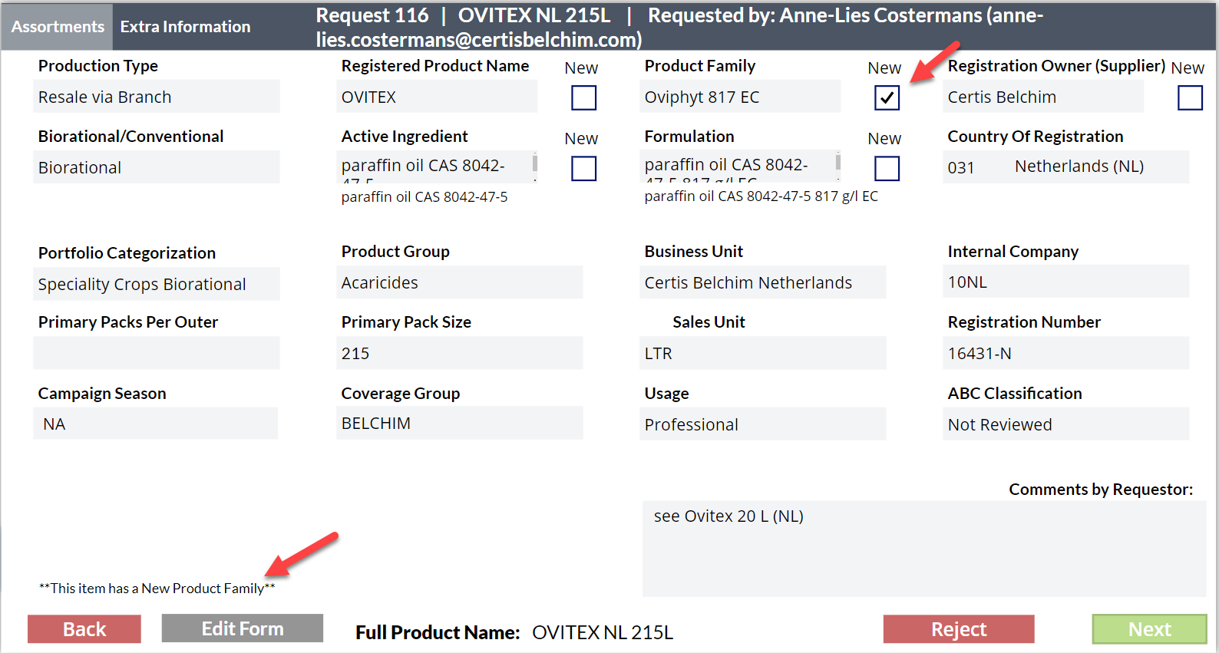

## Contacting information

We hope this manual has given you some more insight into the app. To learn more about the app it is recommended to look around the app and test the functions. If there are any remaining questions, do not hesitate to contact the Support Power Platform <support.powerplatform@certisbelchim.com>.

We wish all a pleasant time using this app. Any feedback will be appreciated and can be given by email given above.